Bank Management System

Database Design

Version 1.0

Revision History

|  |  |  |  |
| --- | --- | --- | --- |
| **Date** | **Version** | **Description** | **Author** |
| 20/03/2021 | 1.0 | Final Draft | An Thị Phương |
|  |  |  |  |
|  |  |  |  |

A description of the persistent data storage perspective of the Bank Management System

# Entity Relationship Diagram

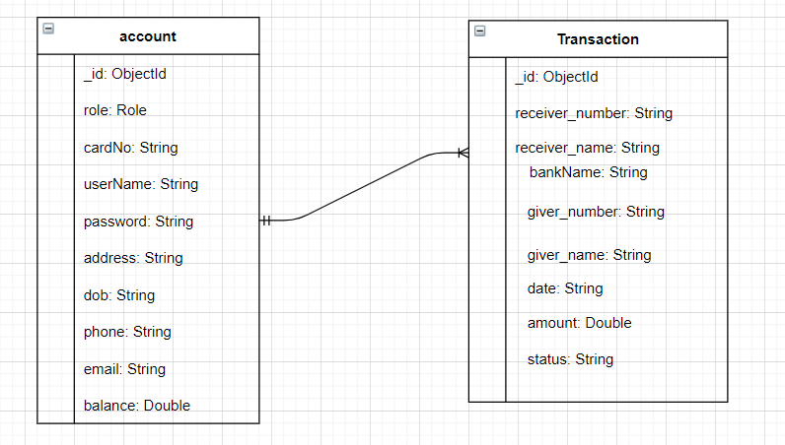

# Data dictionary

## Account

|  |  |  |  |  |  |  |  |
| --- | --- | --- | --- | --- | --- | --- | --- |
| Table | Column | Type | Description | Length | Incl. in PK | Nullable | Unique |
| account | _id | ObjectId | Unique identifier for each account | - | True | False | True |
| role | String | Admin or user | - | False | False | False |
| cardNo | String | Account number of the account | - | False | False | True |
| username | String | Name of user | From 4-32 characters | False | False | True |
| password | String | Password of user | From 6 to 32 characters | False | False | True |
| address | String | Address of user | - | False | True | False |
| dob | String | Date of birth | - | False | True | False |
| phone | String | Phone number of user | - | False | False | True |
| email | String | Email of user | - | False | False | True |
| balance | Double | Available amount in the account | - | False | True | False |

## Transaction

|  |  |  |  |  |  |  |  |
| --- | --- | --- | --- | --- | --- | --- | --- |
| Table | Column | Type | Description | Length | Incl. in PK | Nullable | Unique |
| transaction | _id | ObjectId | Unique identifier for each transaction | - | True | False | True |
| receiver_number | String | Account number of receiver | - | False | False | True |
| receiver_name | String | Account name of receiver | - | False | False | True |
| bank_name | String | Name of bank (BIDV by default) | - | False | False | True |
| giver_number | String | Account number of giver | - | False | False | True |
| giver_name | String | Account name of giver | - | False | True | True |
| date | String | Date of birth | - | False | True | False |
| amount | String | Amount to tranfer | - | False | False | False |
| status | String | Status of transaction | - | False | False | False |